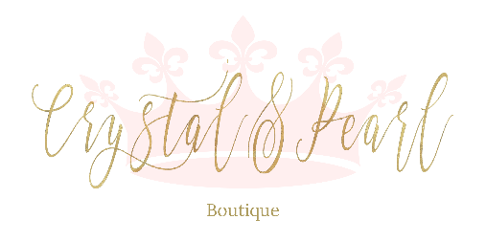
FAIRY TALE COLLECTION DRESSES - SIZE CHART

Size | Chest  Circumference  (cm) | Waist  Circumference  (cm) | Dress length from arm pit  (Aline-Silhouette)  cm | Dress length from arm pit  (Princess Silhouette)  cm
26 (Age 1-2) | 52cm | 52cm
28 (Age 3-4) | 56cm | 56cm | 80cm | 90cm
30 (Age 5-6) | 60cm | 60cm | 85cm | 95cm
32 (Age 7-8) | 64cm | 62cm | 90cm | 100cm
34 (Age 9) | 68cm | 64cm | 95cm | 105cm
36 (Age 10) | 72cm | 66cm | 100cm | 110cm
38 (Age 11) | 76cm | 68cm | 105cm | 115cm
40 (Age 12) | 80cm | 70cm | 110cm | 120cm

